☕ Coffee House Website: Project Report

1. Executive Summary
This report details the "Coffee House" web development project. The core aim of this project was to build a modern, attractive, and highly effective single-page website for a local coffee shop. A primary focus during development was ensuring the website was fully responsive, meaning it looks and functions perfectly across all devices, from large desktop screens to small mobile phones.
The website successfully showcases the business's main offerings, including an introductory section, an 'About Us' description, and a comprehensive 'Menu' featuring 12 different coffee items. This straightforward design makes the browsing and ordering process easy and intuitive for potential customers.

2. Introduction and Project Motivation

2.1. Project Introduction
This project served as a practical application of fundamental Web Development principles. The "Coffee House" site acts as a modern, digital storefront, allowing customers to easily view the product catalog (the menu) and learn about the establishment without needing to visit physically.
It’s a great example of how basic technologies like HTML, CSS, and JavaScript can be combined to create a clean, functional commercial asset.

2.2. Motivation and Goals
In today's digital age, having an online presence is non-negotiable for any business, no matter how small. Our motivation was driven by three main goals:
- To Create a User-Friendly Platform: We aimed for a design that is aesthetically pleasing and intuitive, ensuring a smooth experience for every visitor.
- To Deliver a Flawless Responsive Design: The site needed to adapt seamlessly to different screen sizes to avoid frustrating mobile users.
- To Demonstrate Core Web Skills: This project was a tangible way to showcase proficiency in structuring, styling, and adding interactivity using core web languages.

3. Detailed Project Objectives
The successful completion of this project was measured against the following key objectives:
Objective | Description | Status
Main Page Structure | To use HTML to establish the necessary sections: Home, About, Menu, and Contact. | Successfully Achieved
Menu Display | To neatly present 12 distinct coffee items, each complete with an image, name, short description, and price. | Successfully Achieved
Responsive Header | To implement a functional Hamburger Menu for small screens, allowing mobile navigation without cluttering the display. | Successfully Achieved
Aesthetic Design | To give the website a warm, professional, and inviting look consistent with a real-world coffee house theme. | Successfully Achieved

4. Technical Specifications
The entire project was developed using the standard Client-Side web technology stack.

4.1. Technologies and Tools Used
- HTML5 (HyperText Markup Language): Used to define the logical structure, sections, and semantic meaning of the entire website content.
- CSS (Cascading Style Sheets): Used for all visual styling, including colors, fonts, layout (Flexbox/Grid), and implementing the mobile-first responsive adjustments.
- JavaScript: Used sparingly to handle basic client-side interactivity, primarily the toggling logic for the mobile navigation menu and the scrolling action for the 'Order Now' button.

4.2. File Structure
The project maintains a simple and efficient file hierarchy:
File Name | Purpose
index.html | The single main file containing all structure and content.
style.css | Contains all the CSS rules for presentation and responsiveness.
script.js | Contains all the JavaScript functions for interactivity.
[Image Files] | Local image assets (e.g., latte.webp, affgatho.webp) used for the menu display.

5. Design and Layout Implementation
The design strategy focused on providing a smooth, distraction-free browsing experience for the user.

5.1. Navigational Structure
- The Header: A persistent header element sits at the top, housing the "☕ Coffee House" logo and the main navigation links (Home, About, Menu, Contact).
- Mobile Adaptability: A crucial design feature is the mobile menu. On small screens, the traditional links disappear, replaced by a simple Hamburger Icon (☰). Clicking this icon reveals the navigation bar, ensuring both a clean look and full functionality on phones.

5.2. Section-wise Design
- Home Section: This is the landing area, featuring a large headline and a compelling call-to-action button (Order Now), which automatically scrolls the user down to the menu.
- About Section: Provides a concise paragraph detailing the company's ethos ("We serve freshly brewed coffee made with love and passion.").
- Menu Section (The Star of the Show):
  - The menu items are organized into an attractive and scalable grid layout.
  - Each item is a self-contained card showing the coffee's image, name (e.g., Espresso), a brief description (Strong and bold flavor), and the price (e.g., ₹120).
  - The inclusion of 12 distinct items (from hot Espresso to chilled Iced Latte) demonstrates content management and layout scalability.

5.3. Visual Design Breakdown (Referencing Screenshots)
The design effectively utilizes a warm, coffee-themed colour palette (dark browns and cream) for a professional look, as seen in the screenshots provided:
- **Home Page:** The use of a high-quality, relevant background image with plants and coffee cups immediately sets a welcoming mood, contrasting strongly with the central "Welcome" text and the bright orange 'Order Now' button, creating clear focus.
- **Menu Layout:** The menu items are displayed using clean, white cards with rounded corners, which makes the images pop and gives a modern feel. The grid structure efficiently manages the 12 items, ensuring easy readability and access on a single page.
- **Footer Design:** The dark footer section (matching the header) provides a solid closure to the page, containing essential contact information and copyright details, which maintains professionalism.

6. Code Walkthrough and Implementation

6.4. HTML Code Listing (index.html)
The HTML provides the semantic structure for the website, defining sections, headers, and menu items:
<!DOCTYPE html>
<html lang="en">
<head>
<meta charset="UTF-8">
<meta name="viewport" content="width=device-width, initial-scale=1.0">
<title>Coffee House</title>
<link rel="stylesheet" href="style.css">
</head>
<body>

<!-- Header -->
<header>
<div class="logo">☕ Coffee House</div>
<nav class="navbar" id="navbar">
<a href="#home">Home</a>
<a href="#about">About</a>
<a href="#menu">Menu</a>
<a href="#contact">Contact</a>
</nav>
<div class="menu-icon" onclick="toggleMenu()">☰</div>
</header>

<!-- Home -->
<section id="home" class="home">
<h1>Welcome to Coffee House</h1>
<p>Freshly brewed happiness in every cup!</p>
<button onclick="showMenu()">Order Now</button>
</section>

<!-- About -->
<section id="about" class="about">
<h2>About Us</h2>
<p>We serve freshly brewed coffee made with love and passion. Taste the difference in every sip.</p>
</section>

<!-- Menu -->
<section id="menu" class="menu">
<h2>Our Menu</h2>
<div class="menu-items">

<div class="item">
<img src="Exper.webp" alt="Espresso">
<h3>Espresso</h3>
<p>Strong and bold flavor</p>
<span>₹120</span>
</div>

<div class="item">
<img src="chapchino.webp" alt="Cappuccino">
<h3>Cappuccino</h3>
<p>Creamy and smooth delight</p>
<span>₹150</span>
</div>

<div class="item">
<img src="latte.webp" alt="Latte">
<h3>Latte</h3>
<p>Soft blend with milk</p>
<span>₹130</span>
</div>

<div class="item">
<img src="Chocolate-Coffee.webp">
<p>Chocolate flavored coffee</p>
<span>₹160</span>
</div>

<div class="item">
<img src="amricano.webp">
<h3>Americano</h3>
<p>Strong espresso diluted with hot water</p>
<span>₹110</span>
</div>

<div class="item">
<img src="cold_coffee.webp">
<h3>Cold Coffee</h3>
<p>Chilled coffee served with ice and cream</p>
<span>₹140</span>
</div>

<div class="item">
<img src="caramelo.webp" alt="Caramel Macchiato">
<h3>Caramel Macchiato</h3>
<p>Rich espresso layered with caramel and milk</p>
<span>₹170</span>
</div>

<div class="item">
<img src="lrish.webp" alt="Irish Coffee">
<h3>Irish Coffee</h3>
<p>Coffee with cream and whiskey flavor</p>
<span>₹200</span>
</div>

<div class="item">
<img src="flat white.webp" alt="Flat White">
<h3>Flat White</h3>
<p>Velvety milk and rich espresso shot</p>
<span>₹140</span>
</div>

<div class="item">
<img src="black coffee.webp" alt="Black Coffee">
<h3>Black Coffee</h3>
<p>Pure and strong black brew</p>
<span>₹100</span>
</div>

<div class="item">
<img src="affgatho.webp" alt="Affogato">
<h3>Affogato</h3>
<p>Espresso poured over vanilla ice cream</p>
<span>₹180</span>
</div>

<div class="item">
<img src="Iced.webp" alt="Iced Latte">
<h3>Iced Latte</h3>
<p>Refreshing cold milk with espresso</p>
<span>₹150</span>
</div>

</div>
</section>

<!-- Contact -->
<section id="contact" class="contact">
<h2>Contact Us</h2>
<p>Email: coffeehouse@gmail.com | Phone: +91 9876543210</p>
</section>

<!-- Footer -->
<footer>
<p>© 2025 Coffee House | Made with ♥ by Harsh Verma</p>
</footer>

<script src="script.js"></script>
</body>
</html>

6.5. CSS Code Listing (style.css)
The CSS file contains all the styling and responsiveness rules, defining the visual aesthetics and ensuring the layout adapts to mobile devices via media queries:
* {
margin: 0;
padding: 0;
box-sizing: border-box;
font-family: 'Poppins', sans-serif;
}

/* Header */
header {
display: flex;
justify-content: space-between;
align-items: center;
background: #3e2723;
color: #fff;
padding: 15px 40px;
position: sticky;
top: 0;
z-index: 1000;
}

.logo {
font-size: 22px;
font-weight: bold;
}

.navbar a {
color: #fff;
text-decoration: none;
margin: 0 15px;
font-weight: 500;
}

.navbar a:hover {
color: #ffb74d;
}

.menu-icon {
display: none;
font-size: 26px;
cursor: pointer;
}

/* Home */
.home {
background: url('Home_page_photo.avif') center/cover no-repeat;
height: 100vh;
display: flex;
flex-direction: column;
justify-content: center;
align-items: center;
color: white;
text-shadow: 2px 2px 4px #000;
text-align: center;
}

.home h1 {
font-size: 45px;
margin-bottom: 10px;
}

.home p {
font-size: 20px;
margin-bottom: 20px;
}

.home button {
background: #ffb74d;
color: #3e2723;
border: none;
padding: 10px 25px;
border-radius: 25px;
cursor: pointer;
font-weight: bold;
transition: 0.3s;
}

.home button:hover {
background: #fff;
}

/* About, Menu, Contact */
.about, .menu, .contact {
padding: 60px 20px;
text-align: center;
}

.menu-items {
display: flex;
flex-wrap: wrap;
justify-content: center;
margin-top: 20px;
}

.item {
background: #fff;
margin: 15px;
padding: 20px;
border-radius: 15px;
width: 250px;
box-shadow: 0 4px 8px rgba(0,0,0,0.2);
transition: 0.3s;
}

.item:hover {
transform: scale(1.05);
}

.item img {
width: 100%;
height: 180px;
border-radius: 10px;
object-fit: cover;
}

.item h3 {
margin: 10px 0 5px;
color: #3e2723;
}

footer {
background: #3e2723;
color: white;
text-align: center;
padding: 15px;
}

/* Responsive */
@media(max-width:768px){
.navbar {
display: none;
flex-direction: column;
background: #3e2723;
width: 100%;
text-align: center;
}

.navbar a {
display: block;
padding: 10px;
}

.menu-icon {
display: block;
}
}

6.6. JavaScript Code Listing (script.js) - Your Code
The JavaScript file handles the interactive elements, specifically managing the mobile navigation toggle and the scroll function for the 'Order Now' button:
function toggleMenu() {
let nav = document.getElementById("navbar");
if (nav.style.display === "flex") {
nav.style.display = "none";
} else {
nav.style.display = "flex";
}
}

// Scroll to menu section
function showMenu() {
document.getElementById("menu").scrollIntoView({ behavior: "smooth" });
}

7. Results and Evaluation

7.1. Successful Outcomes
- Full Functionality: The final website operates smoothly, with all sections loading and navigation working correctly on a standard browser.
- Complete Menu Catalog: The inclusion of 12 detailed menu items provides a strong showcase for the business's offerings.
- Maintainable Code: The code structure is clean, commented, and follows web standards, making it easy to maintain or expand in the future.

7.2. Challenges Faced
The main challenges encountered during development were primarily focused on visual consistency and asset management:
- Responsive Menu Grid: Ensuring the menu grid, with its 12 items, reflowed correctly and maintained visual balance across the wide range of mobile and tablet screen sizes was the key design challenge. This required careful tuning of CSS Media Queries.
- Local Image Paths: The project relies on locally referenced image paths (e.g., Exper.webp). For a live, deployed website, these images would need to be hosted and their paths verified to ensure they load universally.

7.3. Image Asset Utilization
The use of local image files in .webp format for all menu items is a smart choice. The **WebP** format offers superior compression, meaning the images are smaller in file size while retaining high quality. This directly contributes to faster page load times and better performance, especially crucial for a content-heavy section like the Menu.

7.4. Project Output and Visual Evidence
The following pages/figures are included as visual evidence of the successful project output. When finalizing this report, please insert the corresponding screenshots into this section:

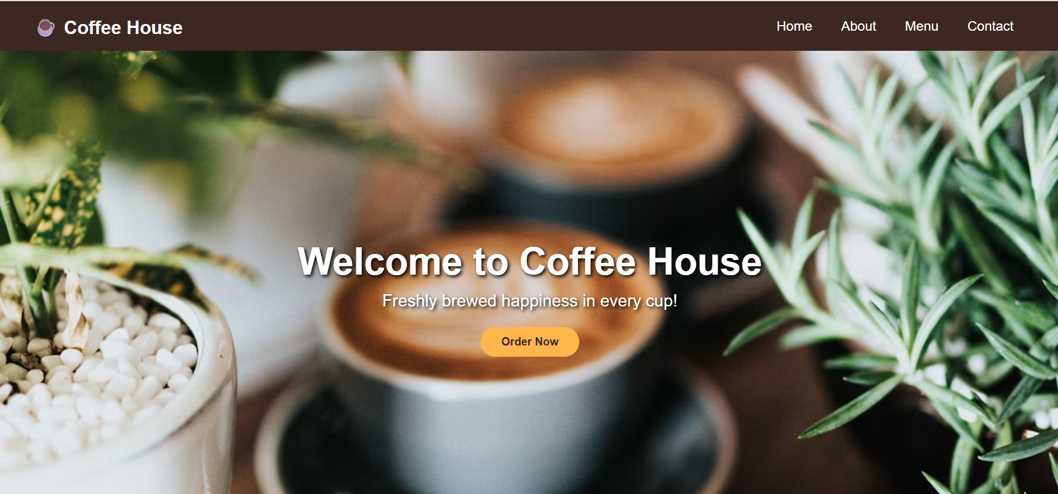
Figure 7.4.1: Home Page Output

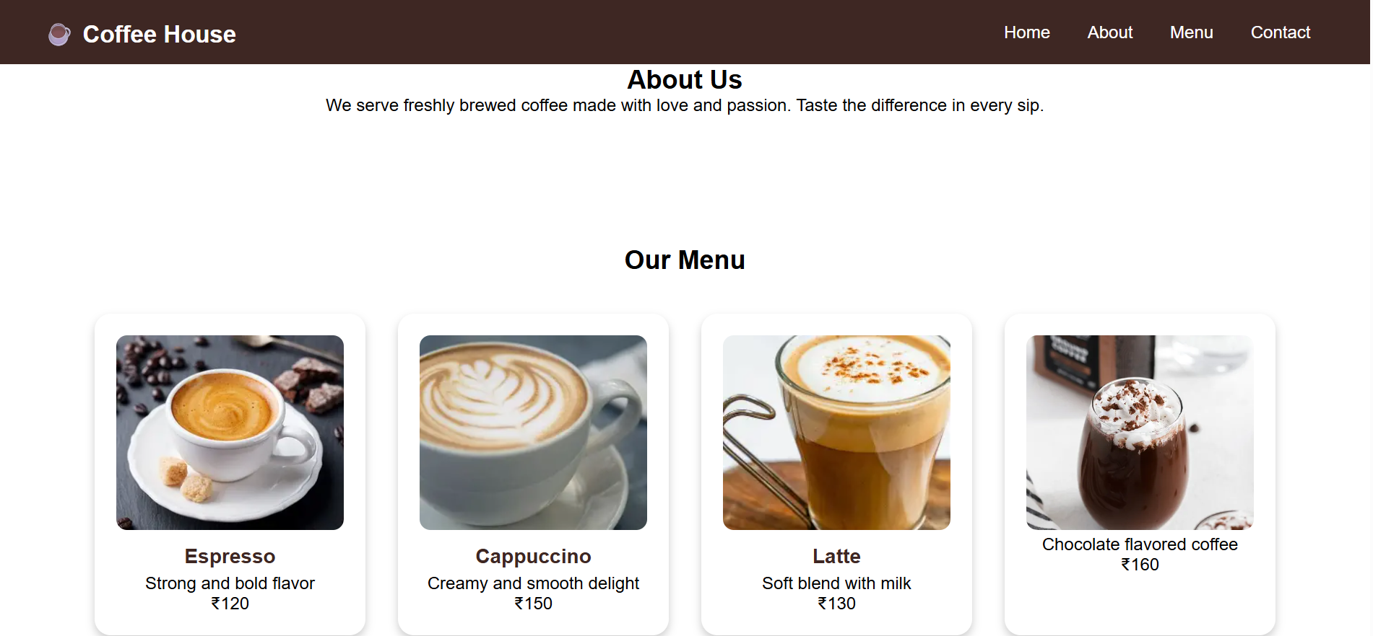
Figure 7.4.2: About

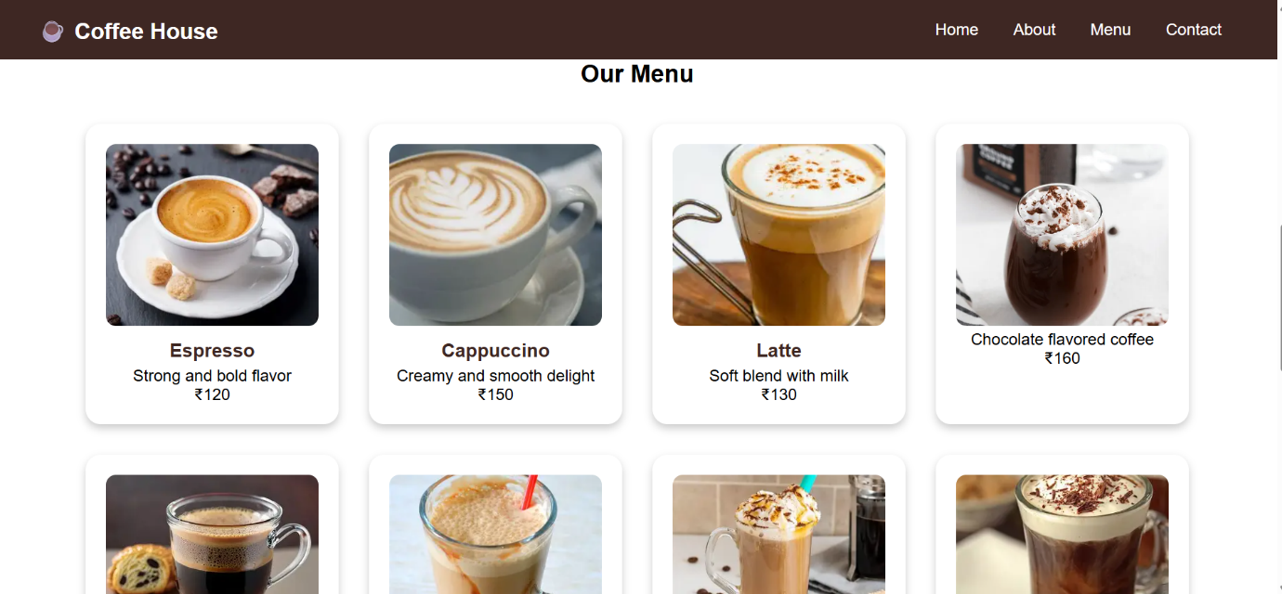

Figure 7.4.3: Menu

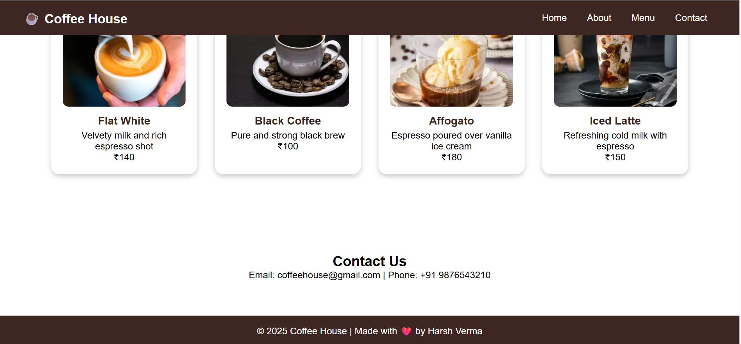

Figure 7.4.4: Footer and Contact

8. Conclusion and Future Scope

8.1. Final Conclusion
The "Coffee House" website project is a successful demonstration of front-end web development skills. It achieved its goal of creating an attractive, responsive, and informational single-page site using HTML, CSS, and JavaScript. The project strongly validates the understanding of layout management, navigational design, and basic interactivity required for modern web applications.

8.2. Future Enhancements
To take this project to the next level, the following features are recommended:
- **Online Ordering System Integration:** Adding a functional shopping cart, quantity selector, and checkout process. This would require integrating a backend technology (like Python Flask or Node.js) and a database.
- **Performance Optimization:** Further compression and optimization of image files to reduce page load times and improve overall site performance scores.
- **Customer Feedback Section:** Implementing a form and display area for customers to submit and view reviews and ratings.

9. References
The following resources were used to guide the structure, syntax, and best practices for the project:
- HTML5 & CSS Documentation (W3Schools / MDN)
- [Your Web Development Course Material/Class Notes]
- [Any other resource used, e.g., a specific tutorial]

